Show

Your

Support

For

*Agriculture*

*Education*!

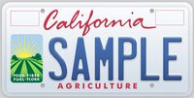

Earn ONE FFA credit for each plate sold!

Purchase a CalAgLicense Plate to help attain the state wide goal of 7,500 plates sold, and the regional goal of 1,000 plates sold!