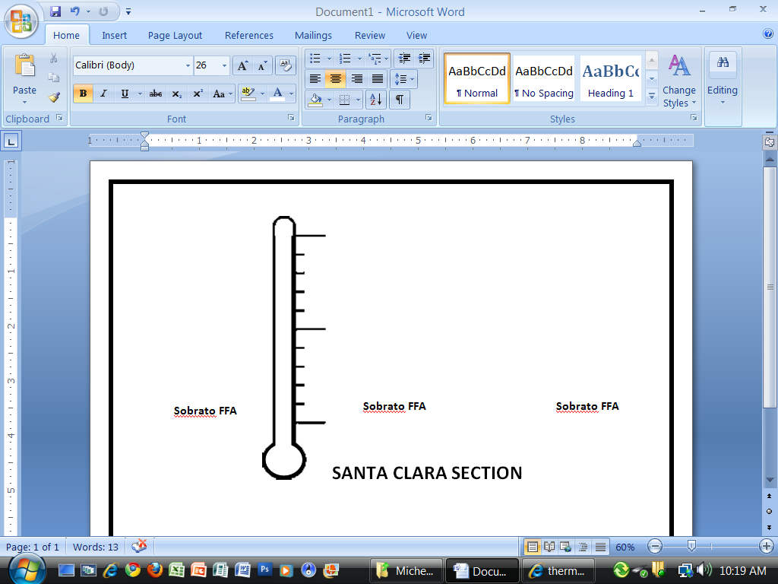**LOS ANGELES SECTION**

**North Hollywood FFA**

**20**

**10**

**Canoga Park FFA**

**2**

**1**

**12**

**6**

**Sylmar FFA**